WHY THE ASSESSMENT AND WHAT HAPPENS WITH THE RESULTS?
By taking just a few minutes to observe each player hitting, running, fielding and throwing, the assessments help us gauge the range of current skills and experience among the players in our league, so that we can organize a list of names for a draft. The draft will occur the following week and is less intense than it sounds. It simply helps us allocate all the players more evenly across all the teams.

DO WE REALLY NEED A “DRAFT” FOR LITTLE KIDS & HOW DOES IT WORK?
Yes, the draft helps us field a league of teams as evenly matched as we can create. We want your kids to have fun while getting better learning solid fundamentals of the sport. While winning and scoreboards are not the primary focus the kids do notice them, and the fun factor goes up when they feel like the games are not lop-sided. The draft helps us prevent one or two teams from being “stacked” with an unfair percentage of kids that have more experience or advanced skills.

WHAT HAPPENS AT THE ASSESSMENT? WHAT DO WE NEED TO DO/BRING?
- Come during the time slot announced earlier this week that is associated with your player’s last name. The earlier you can arrive within that slot, usually the shorter your wait will be.
- There will be a line forming outside the first base dugouts and we will be guiding kids onto the field one at a time for individual assessments. As you get closer to the front of the line, have your player ready with a helmet on and bat in hand. Give their glove to one of the volunteers.
- You can explain to your player(s) ahead of time that they will hit first, taking ~5 pitches from a volunteer parent. When told, on their last pitch they will then sprint to 1st or 2nd base. A volunteer will take their helmet and hand them their glove. Then they will have the opportunity to field several balls and practice throws to first. Note: If your child is interested in pitching, we will use their throws to first to gauge who might also have pitching capabilities. Tell them to whip it! (Note: Minor and above may include more extensive assessments)
- You can pick up your player at the 3rd base dugout where their helmet and bat will also be. Each individual takes less than five minutes to assess. The long part is waiting in line.
- Remember to have your player dressed appropriately and to bring:
  - Helmet
  - Bat
  - Glove
  - Cleats, caps, batting gloves, baseball pants and belts are not a must but are encouraged especially if your player feels comfortable in them.
WHAT HAPPENS NEXT? WHEN DO WE GET OUR TEAMS?
Coaches for each league will meet and complete the draft in the days following the assessment and soon thereafter you will be contacted by your team’s Head Coach. You will receive names of your teammates, your team’s colors, information about practice and game schedules, reminders about the equipment needed and much more.

WHAT EQUIPMENT DO I NEED TO BUY NOW (OR SHOULD I WAIT UNTIL LATER?) WHAT DOES THE LEAUGE PROVIDE?

The basics you will need are:
- Glove (Sizing Chart)
- Batting Helmet (It should be snug enough that it doesn’t move easily, but not painfully tight). A face mask or cheek flap is mandatory.
- Bat (Sizing Chart)
- Cleats are recommended but not mandatory
Additional items needed, but to buy later…these will vary in color from team to team (i.e. Wait to purchase these until your team and colors are known):
- Baseball pants (These are a great lower cost option with elastic waists rather than snaps/zipper, but they still have belt loops)
- Belt for baseball pants
Provided by the League:
- Baseball socks (color will be determined by and match your team)
- Team cap
- Team jersey
For those interested, there is a great second-hand sporting good store next to Mall of Georgia usually with a decent selection of pants, helmets and bats…among other things your kid may quickly outgrow.

Note: For the frugal, used cleats can be risky because if they were stored in a hot attic for example, the glue on the soles can come apart. Academy, Dicks and Sports Authority have a good selection of other items you may prefer to buy new.

WHAT HAPPENS IF MY KID(S) MISSED THE ASSESSMENT? WILL WE STILL BE ON A TEAM?
No. Just kidding…wanted to make sure you were still reading!

Absolutely…yes, you will be placed on a team with or without the assessment (Unless you are on the Wait List and waiting for confirmation of registration). Many of our coaches have been in the league for multiple seasons so we can add direct experience and observation from prior seasons to aid with the draft. Beyond that, we do our very best to spread player experience and skill evenly across all the teams with the knowledge we have. Players of all experience are welcome.

That said, it helps us tremendously to ensure your player has the best experience possible if everyone participates in the assessment, so please join us!

Thank you again for joining us this season! We are looking forward to some great baseball as the school year ramps back up. In the meantime, if you have any questions, you can reach out to our Baseball Commish or Softball Commish for more details.

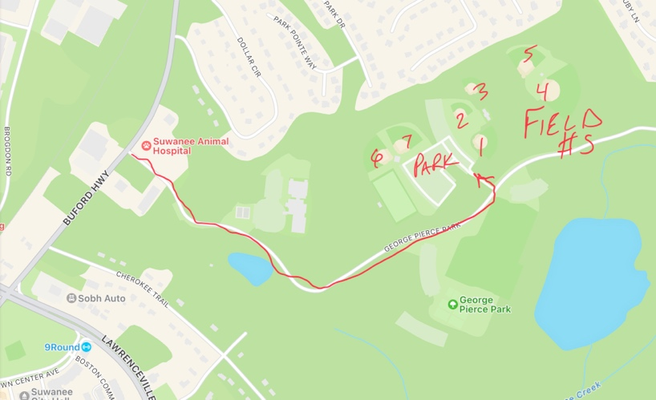
WHEN:
Reminder emails will be sent with final times slots and field locations based on age group and last names

WHERE:
George Pierce Park
55 Buford Highway, Suwanee

